PROJECT REST ENF POINTS :

1. Get Mapping : Inventory

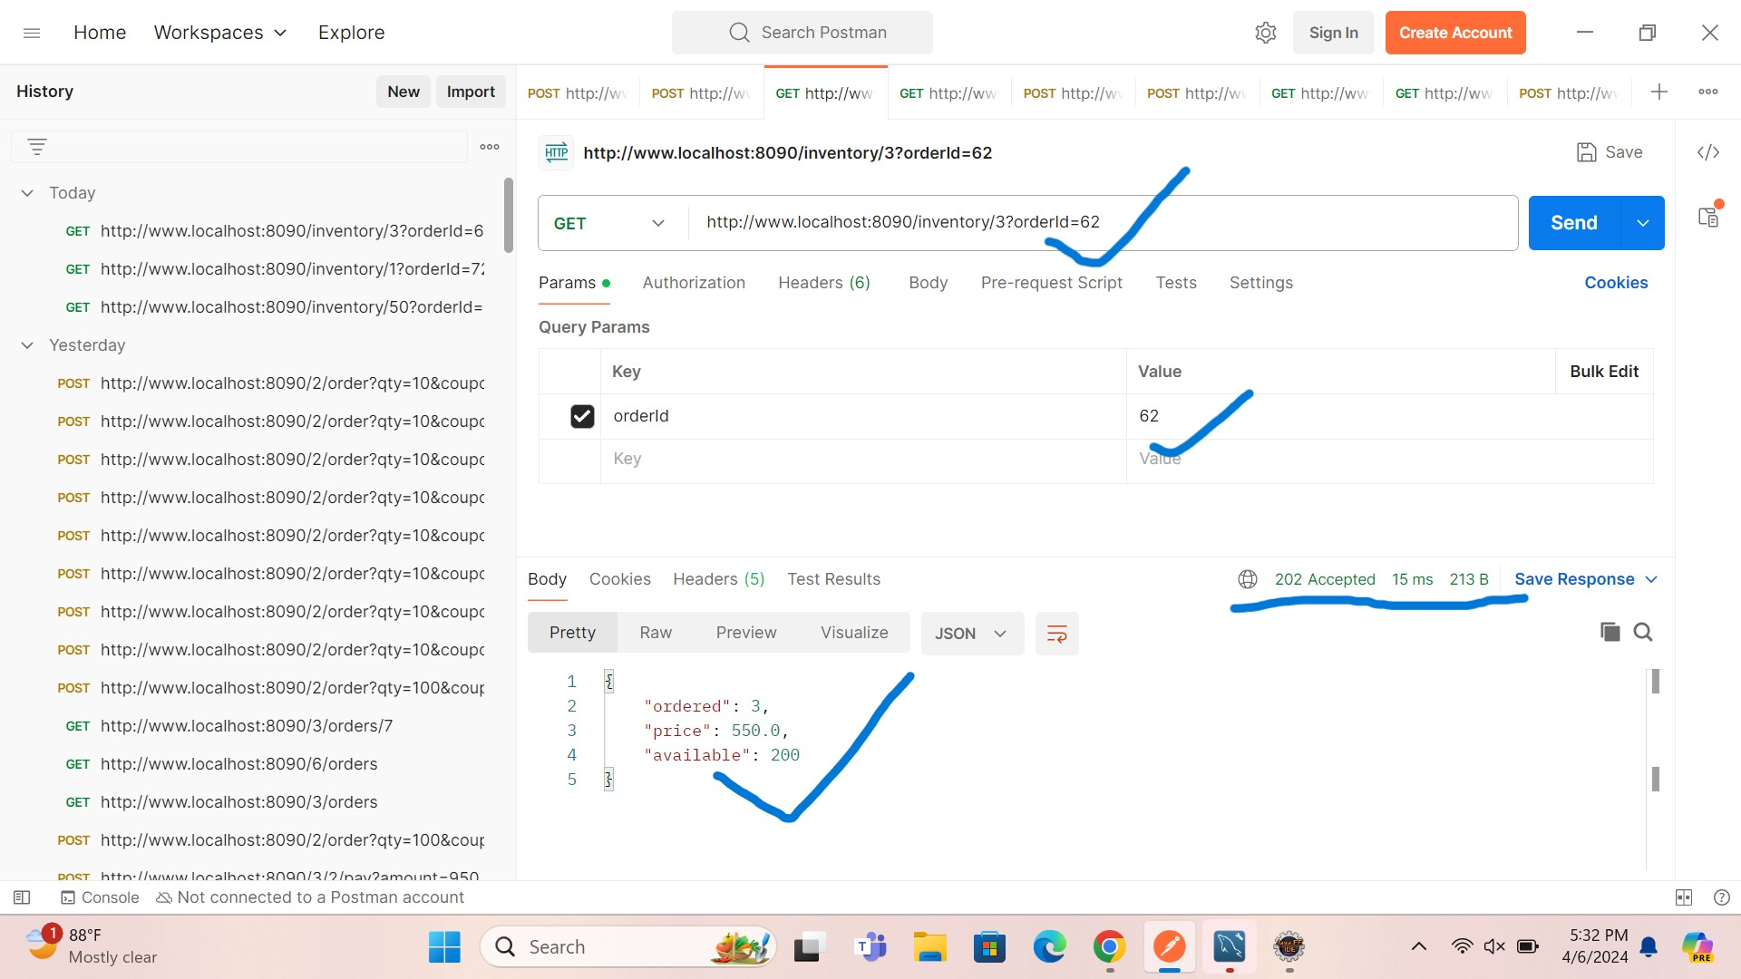

1. GetMapping: Fetch Coupons

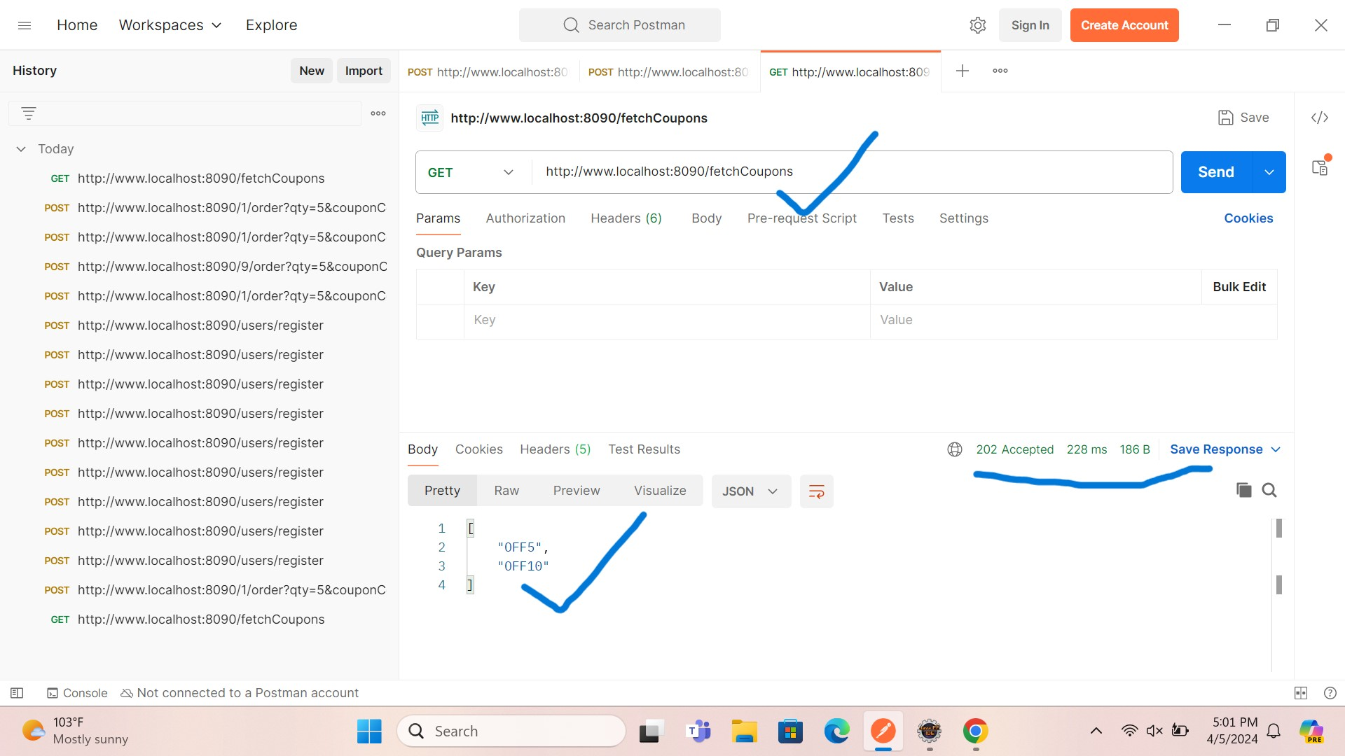

1. PostMapping: a) Ordered

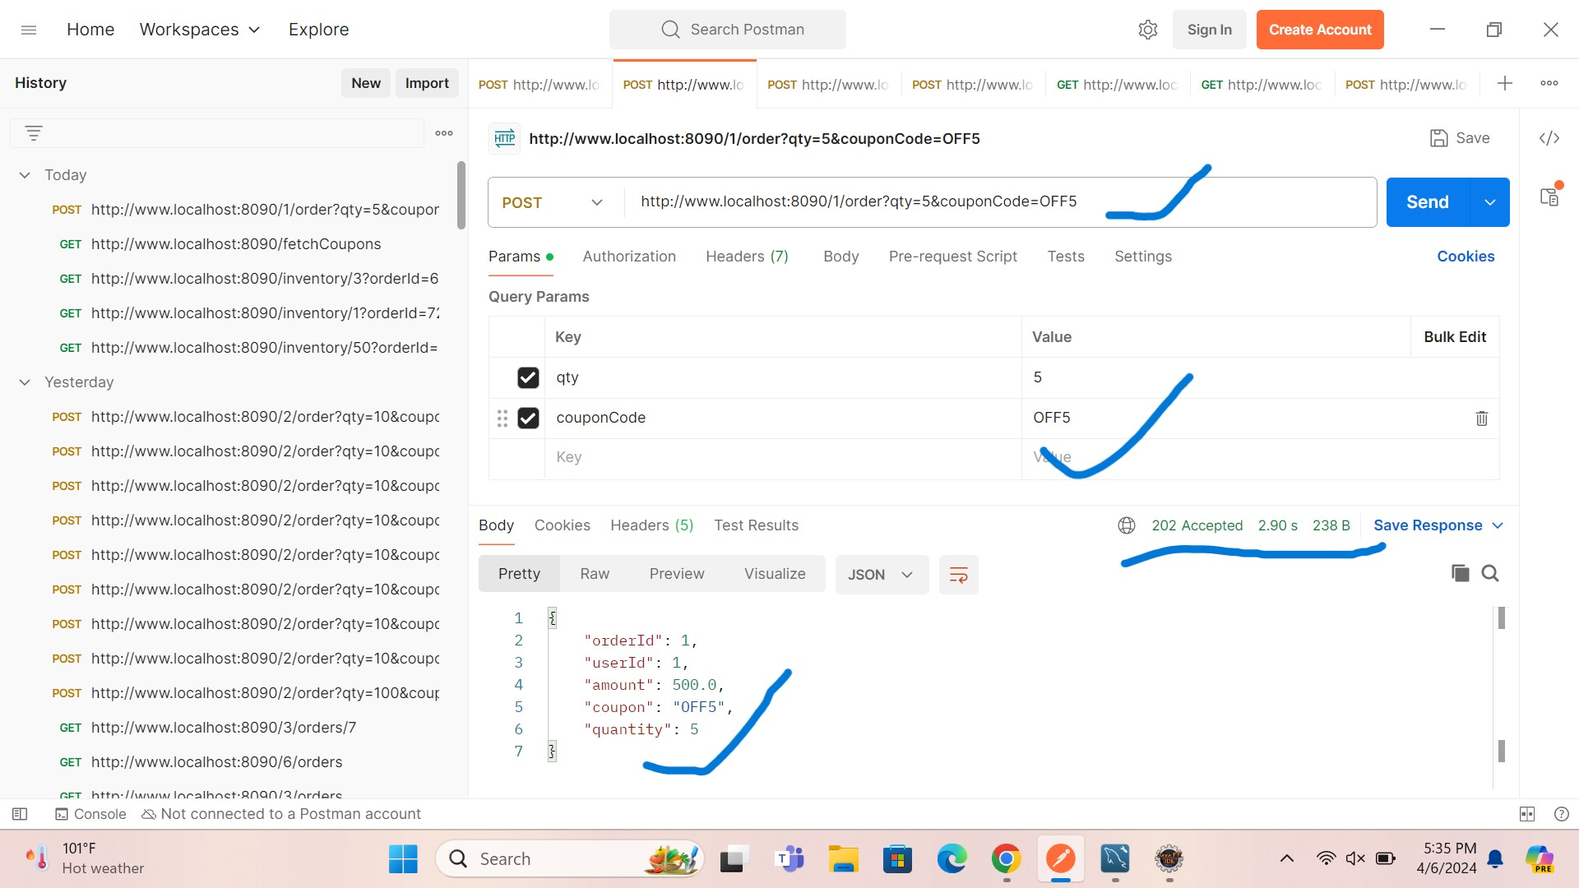

b) If we Enter invalid Quantity: for same url

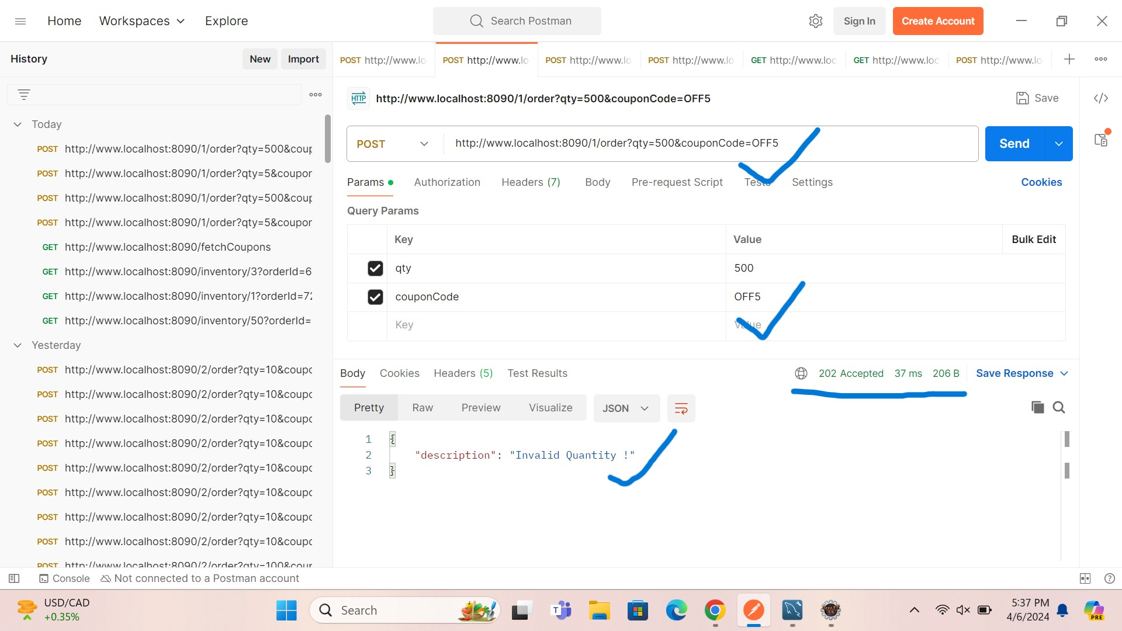

c) If we enter invalid coupon for same url:

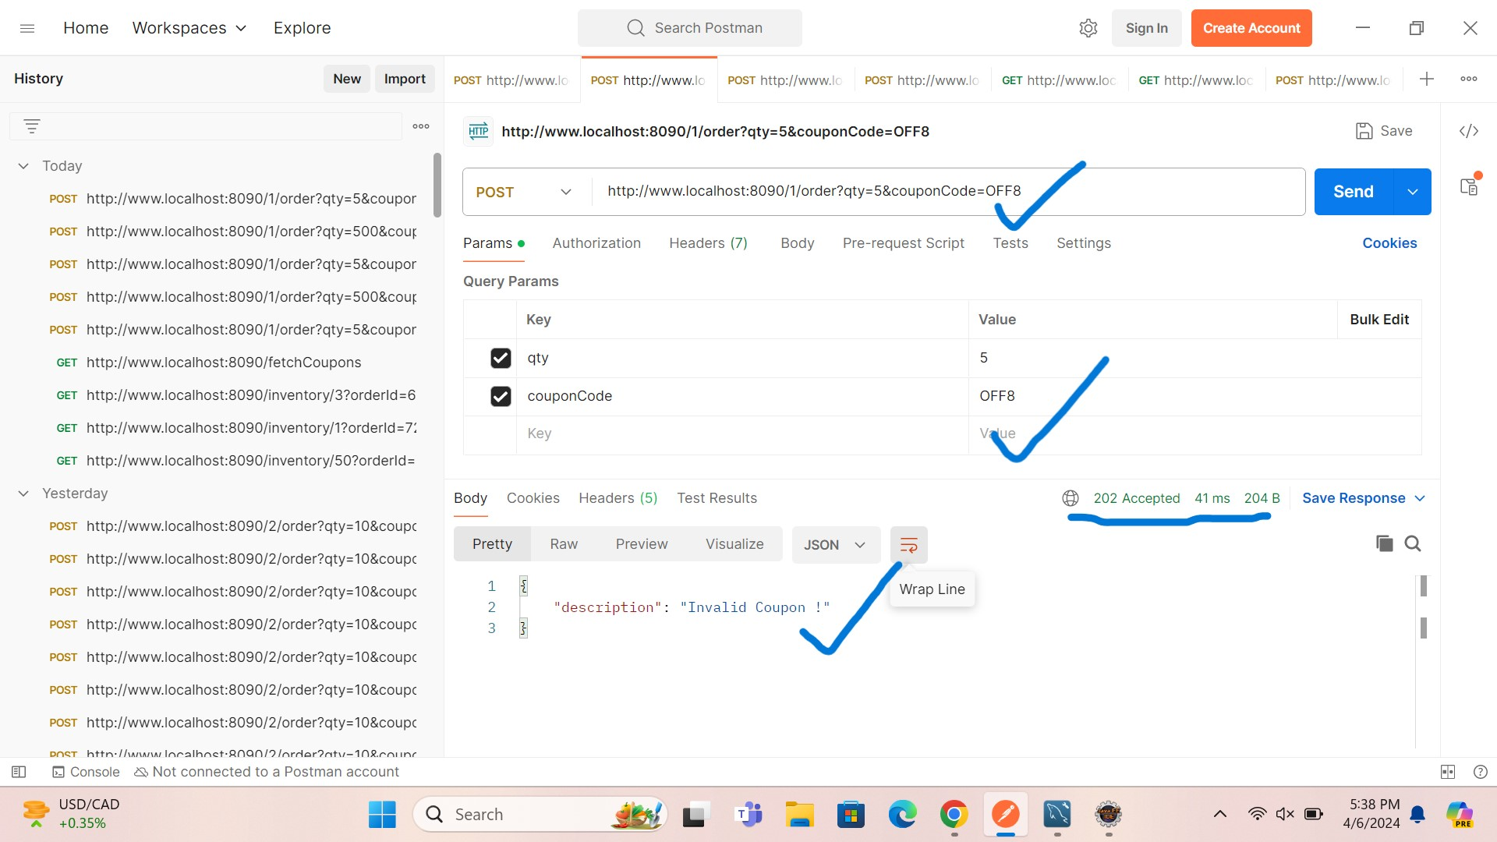

1. Post Mapping: **/Mock the payment API to randomly return any of the following status codes::**
2. **If Transaction is Successful for same url::**

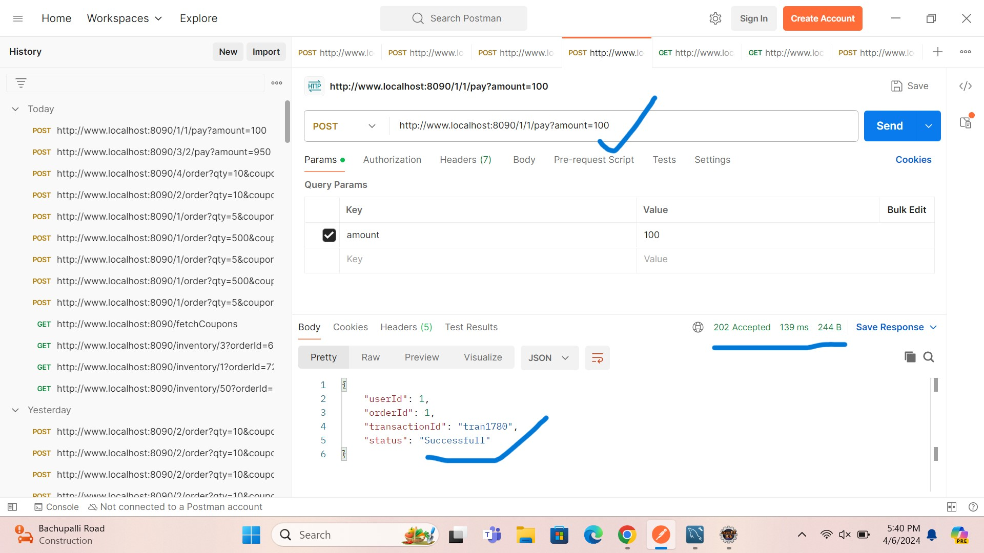

1. If Payment failed as Invalid amount for same url:

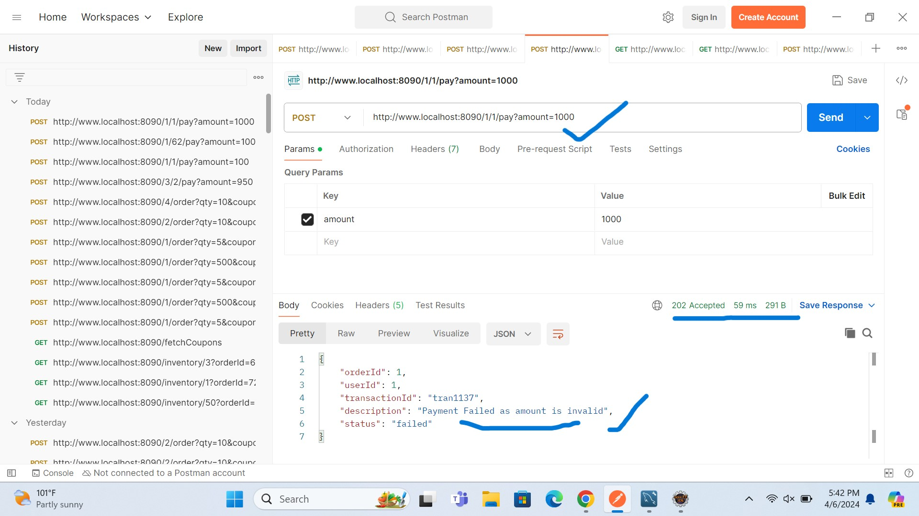

C) If payment failed from Banke for same url::

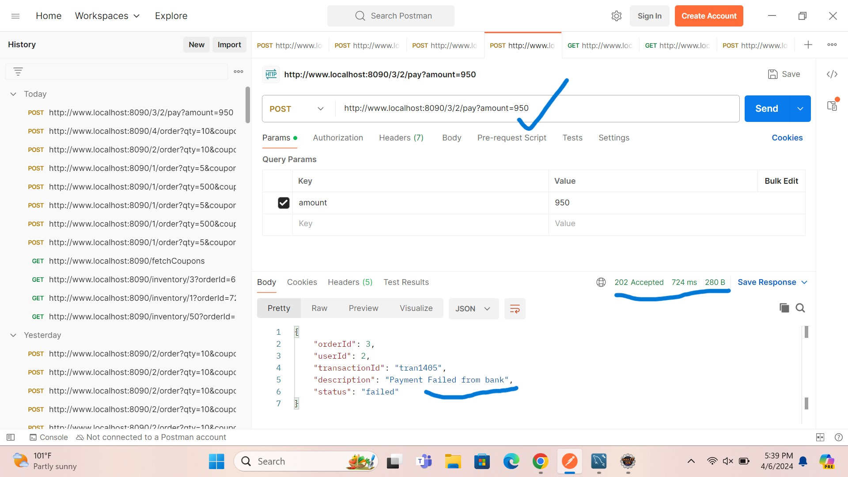

1. Payment failed due to invalid ordered for same url::

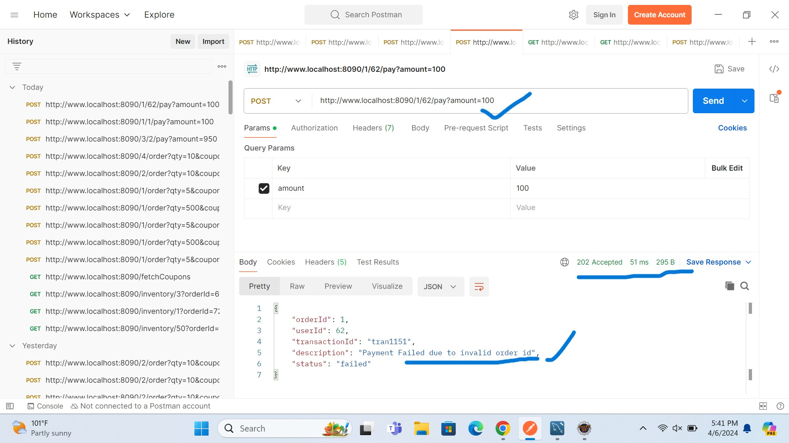

1. GetMapping : Get All orders by userid:

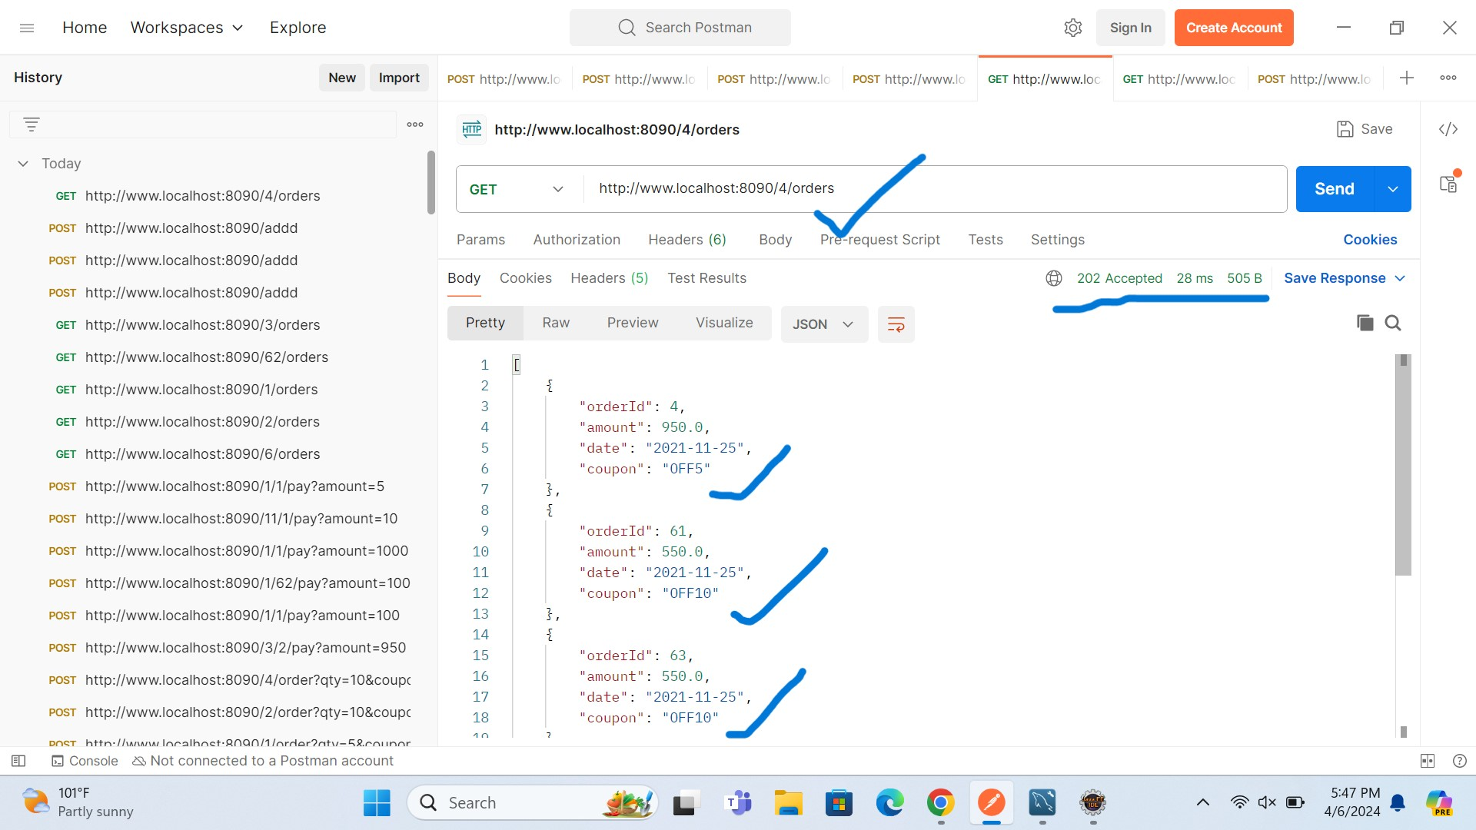

1. GetMapping:: Get Orders by userid and ordered::

